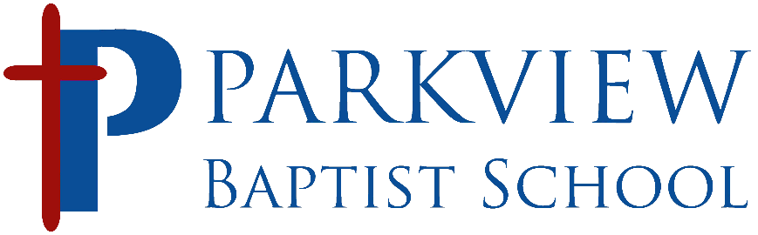

Early Childhood Division (Pre-K, TK and K) CURRICULUM
 | Pre-Kindergarten | Transitional Kindergarten | Kindergarten
Language Arts | - Scott Foresman OWL (Opening the World of Learning)  - Weekly Theme-Based literacy  - Monthly Author Study | - McGraw Hill Reading Wonders  - Weekly Theme Based Literacy | - McGraw Hill Reading Wonders  - Weekly Theme Based Literacy
Math | - Scott Foresman OWL (Opening the World of Learning)  - Weekly Theme-Based Math | - Houghton Mifflin  - Harcourt Go Math | - Houghton Mifflin  - Harcourt Go Math
Science | - Scott Foresman OWL (Opening the World of Learning)  - Weekly Theme-Based Science Experiments | Grade level topics  - Science as Inquiry  - Physical Science  - Life Science  - Earth and Space Science | Grade level topics  - Science as Inquiry  - Physical Science  - Life Science  - Earth and Space Science
Social Studies | - Scott Foresman OWL (Opening the World of Learning) | Grade Level Topics  - Maps  - Globes  - Government | Grade Level Topics  - Maps  - Globes  - Government
Bible | - Positive Action Preschool  - Exploring God’s Love | - Association of Christian Schools International Bible Curriculum | - Association of Christian Schools International Bible Curriculum
Handwriting | - Weekly Theme-Based Draw and Write Journals  - Daily Writer’s Chair and Daily Interactive Morning Messages | - McGraw Hill Reading Wonders | - McGraw Hill Reading Wonders

