**6th 2025-2026 School Supply**

Shopping List:

* Paper Towels – 2 pack
* Clorox Wipes – 1 container
* Kleenex – 2 boxes
* Ear buds
* Pack of 2 highlighters
* Calculator (TI-30XII)
* 2 packages of Crayola Colored Pencils

**6th** **Grade Supply List**

* 4- 100-page composition Notebooks
* 2 glue sticks
* 2 packages of broad tip Expo markers
* 1 zippered binder pouch with 3 holes
* 3 packs of 100- 3x5 inch index cards
* 1 large box pencils (Ticonderoga)
* 1 zippered pencil supply bag
* 15 plastic pocket folders with brads

(4-red, 2-yellow, 2-purple, 2-green,

4 black & 1 blue)

* 1 box Ziplock bags (boys-quart, girls-gallon)

**DO NOT LABEL ANYTHING!!**

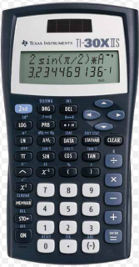**Picture for clarity: Calculator**

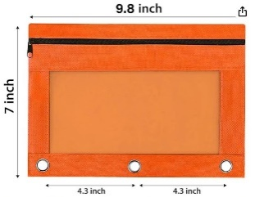Binder Pouch Example